MEDIA RELEASE
16 March 2018
________________________________________________________________

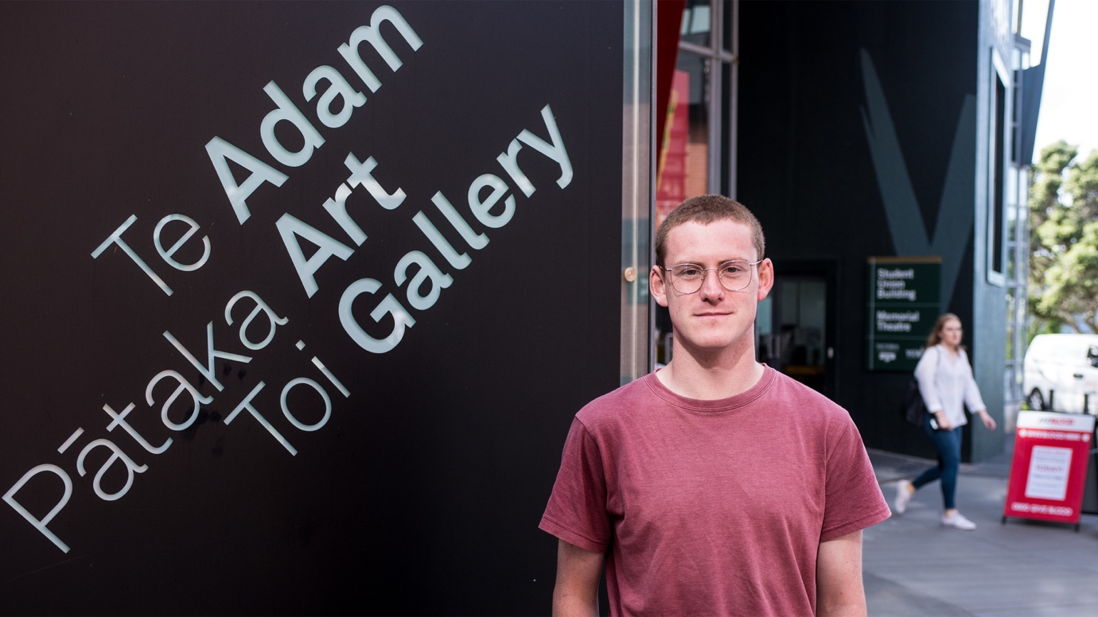

Lachlan Taylor, outside the Adam Art Gallery (photo: Image Services, Victoria University of Wellington)

Adam Art Gallery’s inaugural curatorial intern announced

Art History student Lachlan Taylor has been selected to take up the inaugural curatorial internship at Adam Art Gallery Te Pātaka Toi at Victoria University of Wellington.

Lachlan was selected from a strong field of candidates from throughout New Zealand for the paid internship that offers up to six months’ part-time work. He will start at the Gallery in March while completing his Master’s thesis that offers new insights into our changing relationship with nature through the work of three contemporary artists facing the consequences of climate change.

Lachlan aims to develop his knowledge of curating during the internship with a view to finding full-time work in an art gallery or museum after his studies. Lachlan says: “This is a real opportunity to find out what the job entails. The Adam Art Gallery is an institution I respect and I am looking forward to learning from the team.”

The Adam Art Gallery Internship is a new initiative made possible through a donation from Wellington-based benefactor Barbara Blake. It will see a recent graduate or early-career professional working with the Gallery to learn all aspects of curatorial work and to develop their own project that will feed into the Gallery’s programme.

Adam Art Gallery director Christina Barton says this opportunity further embeds the Gallery in the university context, proving its worth as a training ground for those interested in pursuing a career in the visual arts.

For more information contact Christina Barton on 04-463 5254 or tina.barton@vuw.ac.nz.

Issued by Victoria University of Wellington Communications & Marketing. Jolene Williams, Communications Adviser, can be contacted by emailing jolene.williams@vuw.ac.nz or phoning (04) 463 6385.

Victoria University of Wellington: Capital thinking. Globally minded.

