MEDIA RELEASE

28 September 2018
___________________________________________________________

Unique photography exhibition illuminates the life of Peter McLeavey

Adam Art Gallery Te Pātaka Toi at Victoria University of Wellington is proud to present its final exhibitions for 2018, including an extensive presentation of the photography collection of the late gallerist Peter McLeavey (1936–2015).

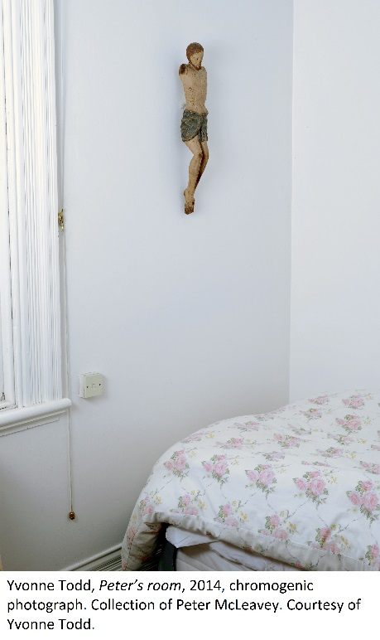
Still looking: Peter McLeavey and the last photograph is co-curated by Professor Geoffrey Batchen from the University’s Art History programme and alumna Deidra Sullivan. The pair say this is a singular opportunity for New Zealanders to see an eclectic range of more than 90 photographic works, many of them by key figures from the history of photography.
“It’s very unusual to see an exhibition like this here in Wellington,” says Professor Batchen. “Peter collected international photography with a real sense of purpose. When he liked a photographer, he collected three or four photographs by them.
“The photographs he acquired were often the best possible prints available—he bought from the leading dealers in the world, and he bought the best.”
After McLeavey’s death in 2015, his widow, Hilary, inherited the collection, but even she has never seen it in its entirety.
“Peter was quite a private person, and he had a very personal relationship with the pieces he collected—he kept them close to himself,” says Deidra, who has worked with Hilary to catalogue the collection.
A majority of the works from the collection are presented publicly for the first time, including masterpieces from internationally celebrated photographers William Henry Fox Talbot, Dorothea Lange, Robert Frank, Francis Frith and Charles Clifford, and important New Zealand photographers such as Laurence Aberhart, Peter Black, Andrew Ross and Yvonne Todd.
As well as a providing an opportunity to see outstanding works of nineteenth and twentieth-century photography, Adam Art Gallery’s director Christina Barton says the exhibition offers rare insights into an iconic Wellingtonian, whose gallery made an indelible mark on the cultural life of the city.
“For decades Peter McLeavey was without doubt one of the most influential figures in the New Zealand art world. From the late 1960s he championed the artists who in turn shaped our recent art history: from McCahon to Walters to Hammond.
“But this exhibition unravels the other side of Peter’s life. Through their careful analysis of the biographical events that led McLeavey to collect these photographs, Deidra and Geoffrey’s exhibition reveals deeply introspective aspects of Peter’s thinking—his Catholic faith, his meditations on finitude and the profound sensitivity he had for understanding what it meant to live in this part of the world.”
Alongside this exhibition will run Solid State: Works from the Victoria University of Wellington Art Collection, which brings together a number of recent additions to the collection.
With works by Phil Dadson, Fiona Connor, Richard Frater, Simon Ingram, Daniel Malone and Dane Mitchell, Solid State explores a range of recent approaches to art making that are research-based and delve into fields of knowledge such as chemistry, physics, electronics and environmental sustainability. It demonstrates how the art collection seeks to build meaningful connections to other disciplines in the university context.
The exhibition’s curator Sophie Thorn says: “As a university collection we don’t shy away from collecting artworks that are research driven. Through their investigations into such phenomena as radio signals, sound recordings in Antarctica and the molecular structure of water, the artists invite us to think about fields outside of art, such as physics and the sciences.
“The exhibition has been a great opportunity to tease out these connections within the gallery spaces.”
Exhibitions: Still looking: Peter McLeavey and the last photograph and Solid State: Works from the Victoria University of Wellington Art Collection
When: 6 October – 20 December 2018
Opening: Friday 5 October, 6pm
Where: Adam Art Gallery Te Pātaka Toi, Victoria University of Wellington, Gate 3, Kelburn Parade, Wellington
Cost: Free
For further details on the exhibitions and upcoming events visit Adam Art Gallery’s website and Facebook page.

For more information contact Stephen Cleland on 04 463 5229 or stephen.cleland@vuw.ac.nz.

Issued by Victoria University of Wellington Communications & Marketing. Sam Burt, Communications Adviser, can be contacted by emailing sam.burt@vuw.ac.nz or phoning (04) 463 5163.
Victoria University of Wellington: Capital thinking. Globally minded.

