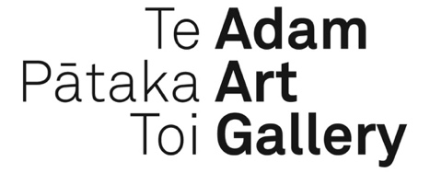

INTERNSHIP APPLICATION INSTRUCTION GUIDE

- Application materials: Applicants must apply in writing and must include a completed Cover Form (provided by the Gallery), a CV, and a cover letter which outlines what they would bring to the role and their areas of interest and expertise. These must align with the vision and mission of the Gallery. Applicants should visit www.adamartgallery.org.nz where they will find information including the Adam Art Gallery vision, mission, exhibition history and information about Victoria University’s Art Collection.
- Deadline: Applications should be sent by email to ann.gale@vuw.ac.nz no later than 5pm on 18 January 2019.
- Eligibility: The internship is open to students/graduates of Art History and other relevant disciplines including but not restricted to Museum & Heritage Studies, Fine Arts, Visual and Cultural Studies, etc, and early-career professionals, based in New Zealand.
- Timeline: A short-list will be prepared in the week beginning 21 January. Shortlisted candidates will be invited to write a short submission identifying a project from a list of options they wish to work on and why. This will be due Friday 1 February. We will interview on 10 and 11 February or the following week.
- Hours and duration of internship: This will be based on discussions with the successful candidate, but the position will start in or after March 2018. Working hours will be negotiated, but the maximum is 400 hours. Examples of possible schedules are: 6 months working 15 hours/week; 3 months working 30 hours/week; or something in between.
- Further advice to applicants: you will be given the opportunity to get properly involved in a project. The project you work on may not be realised in the timeframe of the internship, however you will be acknowledged in published material and if required, will be involved informally in seeing your work through to completion. For example, this may entail editorial feedback on copy provided for wall texts or publications; and/or invitations to speak as part of the public programme. The gallery will provide support by providing feedback and ongoing mentoring and advice.
- The value of being an Adam Art Gallery Intern will be long-term. The intern will become one of a cohort acknowledged on the Gallery’s website and connected over time with other alumni. Their work at the gallery will be acknowledged and remembered and can be used for future career development.

Key documents
- 2019 AAG Internship Media Release
- 2019 AAG Internship Role Description
- 2019 AAG Internship Application Instruction Guide
- 2019 AAG Internship Cover Form

