

**MEDIA RELEASE**

17 September 2020

**___________________________________________________________**

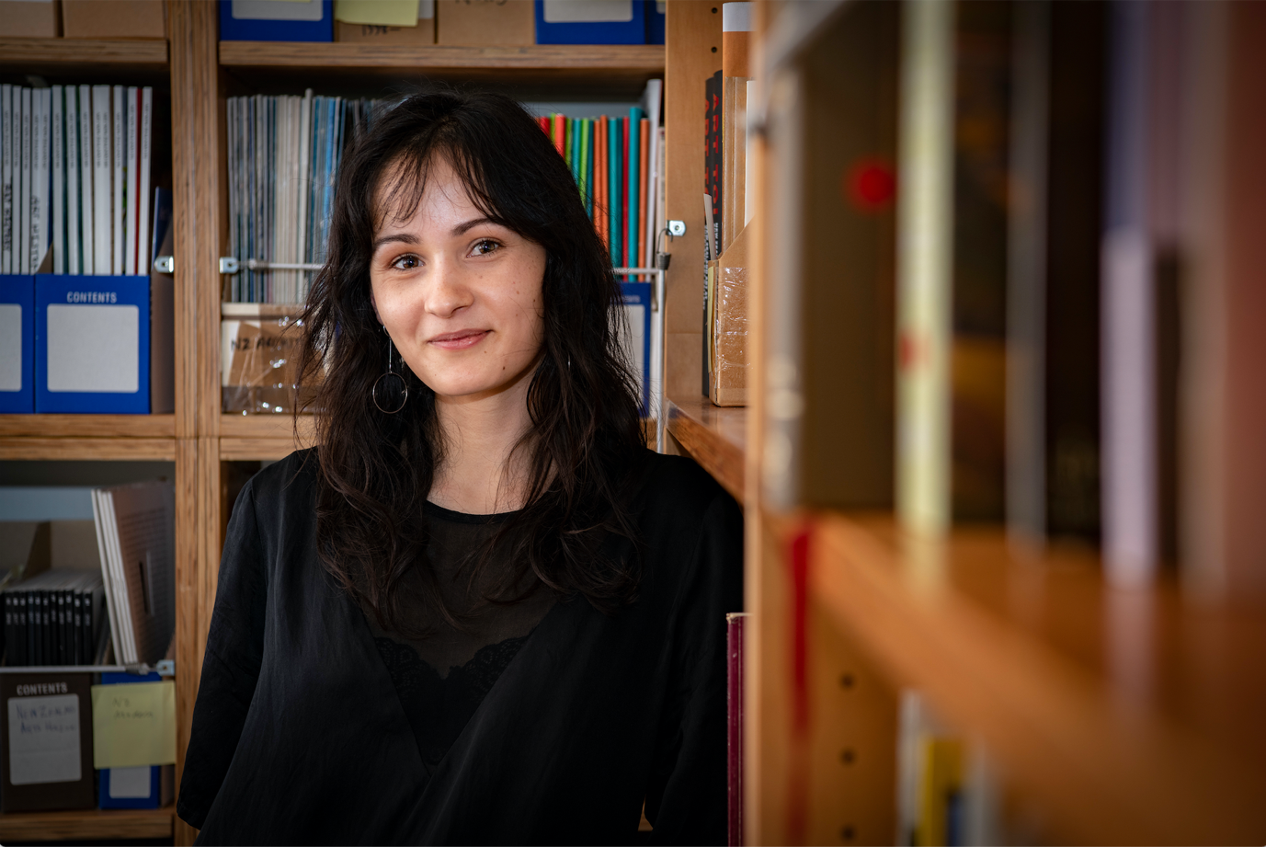

Millie Riddell in the New Zealand Art Archive administered by Adam Art Gallery. Photo: Robert Cross, Te Herenga Waka—Victoria University of Wellington.

**Adam Art Gallery’s new intern announced**

Millie Riddell has started her six-month stint as the latest Adam Art Gallery Intern at Te Herenga Waka—Victoria University of Wellington. She has a BA Honours degree in Art History from the University and has just completed an MA at the Courtauld Institute of Art in London.

Millie returned to New Zealand in March due to the COVID-19 pandemic and wrote her thesis on New Zealand expatriate and pioneer of video art Darcy Lange in lockdown in Nelson.

Adam Art Gallery is delighted to be able to offer her the internship, after delaying the appointment process because of the pandemic.

Millie was selected from an exceptional field of candidates. She will be working with the Adam team on all aspects of the Gallery’s work, with a special focus on developing her knowledge of the New Zealand Art Archive that is now administered by the Gallery and drawing on this to improve knowledge of and access to its holdings. She hopes to publish her research in some form before the conclusion of the internship in February 2021.

Millie says, “I am excited to be working at the Adam to develop my own project with the New Zealand Art Archive, and I am especially looking forward to learning from the team about all the aspects of the Gallery’s work.”

The [Adam Art Gallery Internship](http://www.adamartgallery.org.nz/learning-opportunities/internship/) is now in its third year. Alumni Lachlan Taylor and Nina Dyer are both working in the arts sector since undertaking their internships with the Gallery.

Adam Art Gallery Director Christina Barton says, “I am proud of the role we are playing to introduce young people to the possibilities of working in our sector and am confident we are helping create a network of committed and talented individuals who care about the visual arts in Aotearoa New Zealand.”

The initiative, which provides a part-time paid position for the successful candidate, has been made possible through a donation from Wellington-based benefactor Barbara Blake. Barbara believes “learning on the job with the talented and dedicated team at Adam Art Gallery is an important opportunity at a pivotal stage in their professional life”.

**For more information contact Christina Barton on 04 463 5254 or** [christina.barton@vuw.ac.nz](mailto:christina.barton@vuw.ac.nz)**.**

Issued by Te Herenga Waka—Victoria University of Wellington, Senior Communications Adviser—Media Content Guy Somerset, [guy.somerset@vuw.ac.nz](mailto:guy.somerset@vuw.ac.nz), +64 22 563 6589

|  |  |  |
| --- | --- | --- |
|  |  |  |

*Te Herenga Waka* —*Victoria University of Wellington:*

